The romance of revolution (1978-1984)

Blue text refers to potential hyperlinks, leading to other stories

I loved watching the images gradually appear in the trays of pungent chemicals – the toxicity of the stench obliterated by my thrill at the developer washing its magic over the photo paper – bringing back to life a person or a powerful scene I had captured on film days earlier: A mock funeral protesting the assassinations of literacy teachers.

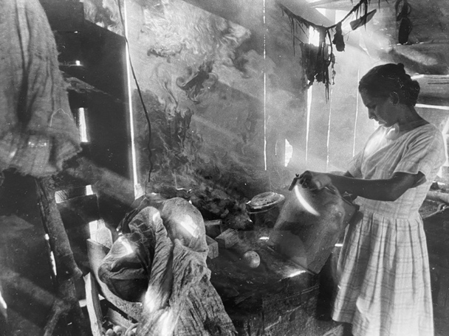
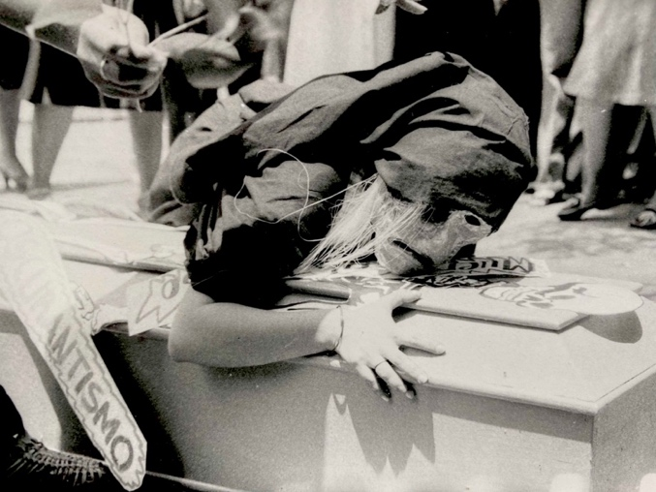
Ministry of Education, Managua, Nicaragua, 1981 Peasant woman in Rama, Nicaragua, 1980?

A tender moment with a campesina cooking over a wood fire, illuminated by rays of sunlight seeping through the slats of her makeshift wooden hut.
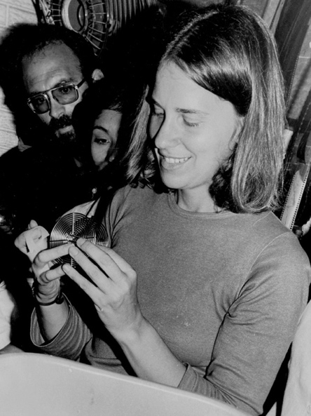
Burrowed within a small darkened closet-turned-photo-lab, teaching literacy teachers how to develop film, I was oblivious to the chatter of my Nicaraguan colleagues on the other side of the door in the Ministry of Education (MED) office in Managua.

But a new voice caught my attention: a memory of a different continent and decade. I detected the accent of a Uruguayan, the ‘jo’ instead of ‘yo’, instantly exposing Latinos from the southern cone. I knew the cadence, and the tone. In my bones.

Giving a workshop in the MED darkroom 1981
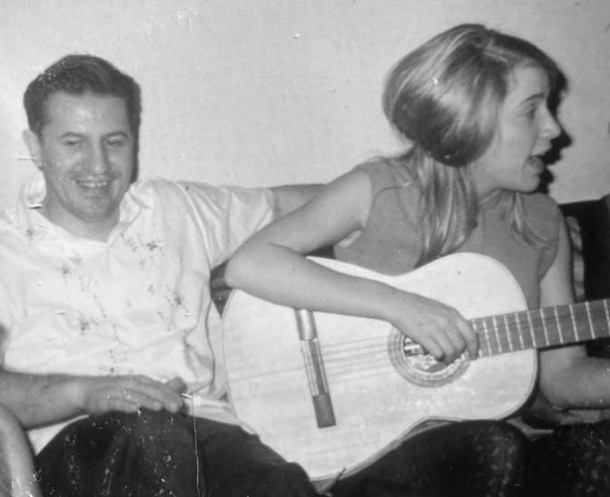
I was transported back to Geneva, Switzerland, 1969, and to the Caselli family who first sparked my interest and ultimately my passion for Latin America and its people. Hector Caselli was my Uruguayan boss, the youth secretary for the World Alliance of the YMCA. He had hired me as the token young person to help him organize a global youth conference, with the intent of rejuvenating the upcoming World Council in Nottingham, UK. I was 23, and Hector, the second youngest staff member, was twice my age at 46.
Hector and me in Geneva, Switzerland, 1969

That dream job, which eventually sent me visiting youth around the world, was made special by my easy and creative collaboration with Hector. But it was his family that fueled my fascination with Latin American culture and politics.

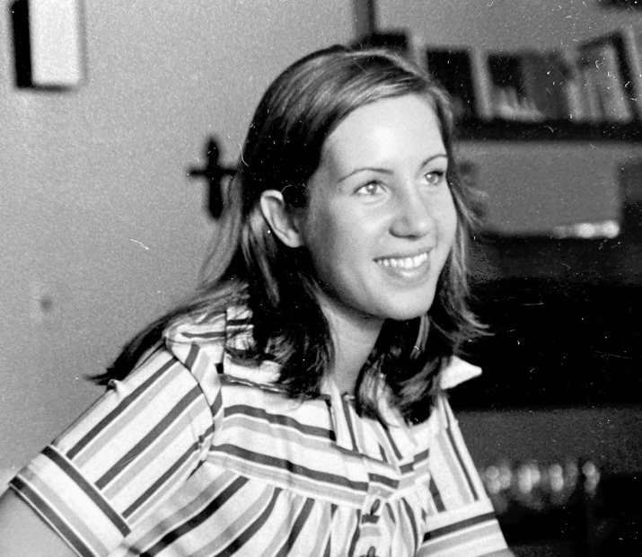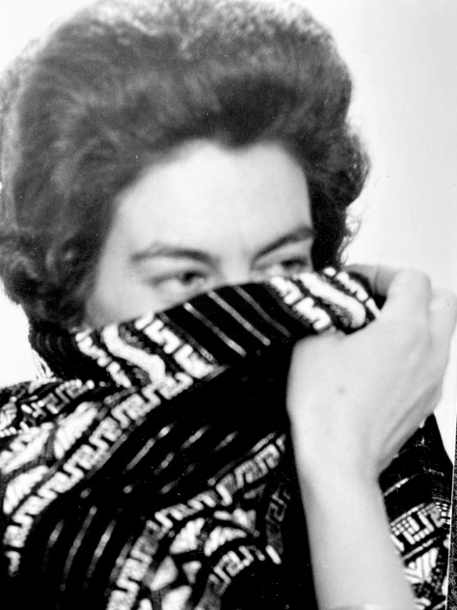
Helena, Geneva, Switzerland, 1969 Elvira, Geneva, Switzerland, 1969

Hector’s 21-year-old daughter Helena was my best friend of that era, an artist with an infectious laugh and a sense of adventure that propelled us to the Greek islands for Semana Santa (Holy Week). Her mother Elvira was warm yet mysterious, self-deprecating in a way that I would come to understand much later. Daniel, her younger brother, was preoccupied with his own multicultural friendships in that small but global city, headquarters for over 300 international organizations. He was there in the background, I paid scant attention to him.

Now, 12 years later, it was Daniel’s voice that drew me out of my darkroom hiding place into the heightened light of the Ministry office. “Que haces aquí, Daniel? (What are you doing here, Daniel??)” Definitely no longer a teenager, he was tall, lanky, moustached, with wavy dark hair and twinkling brown eyes. A camera bag slung over his shoulder. “Me invitaron unos ONGs europeos a documentar la revolución sandinista. (I’m covering the Sandinista revolution for European solidarity organizations”).

Documenting a revolution had not been part of my life plans but a set of converging circumstances had thrust me into this historical moment and space: Nicaragua in the early 1980s, still electric with the energy unleashed by the 1979 overthrow of the Somoza dictatorship by the FSLN, the Sandinista Front of National Liberation.

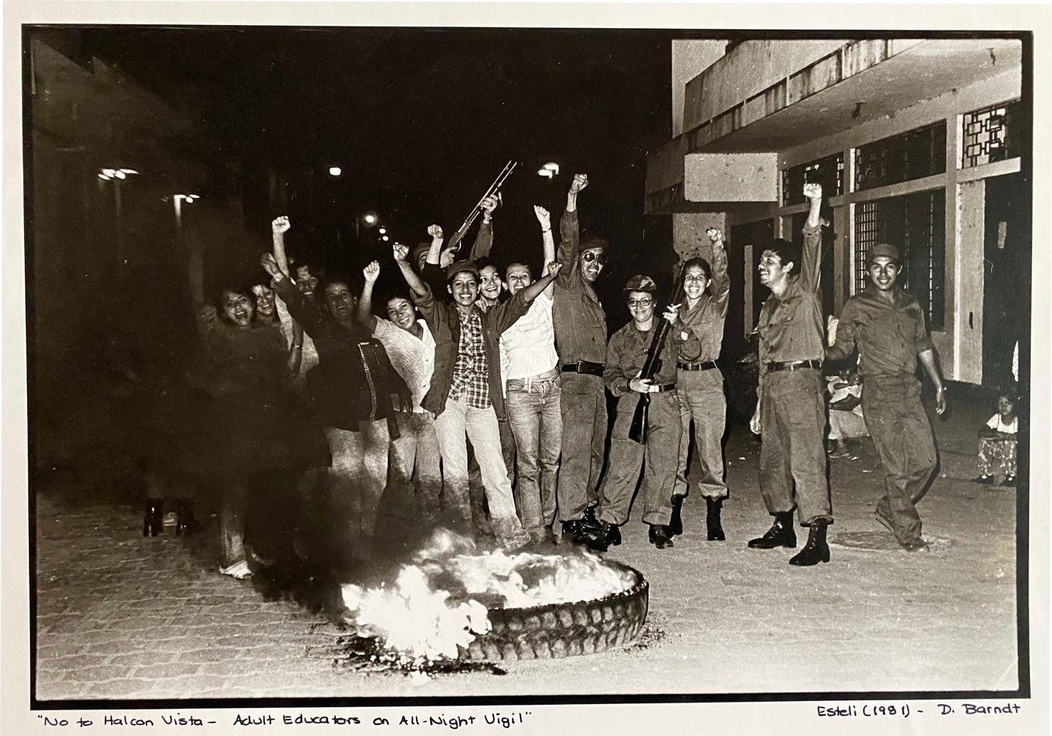

Its first political project also a pedagogical one: to mobilize the entire population to teach reading and writing to disenfranchised peasants and workers, lowering the illiteracy rate from 52% to 12% in five short months.

I had recently completed my PhD on the Peruvian national literacy program, which applied the ‘pedagogy of the oppressed’ methodology of Brazilian educator Paulo Freire. And had been producing photo stories with literacy classes back home in Toronto. One thing led to another, and I had been invited to work with Nicaraguan literacy teachers to produce their own learning materials, applying the Freirean approach of drawing the stories from the learners. So they would learn to read and write their own lives. In a conventional educational world, a truly revolutionary idea.

That fateful encounter with Daniel at the Ministry of Education led to a rediscovery of my friend’s younger brother and my former boss’s son.
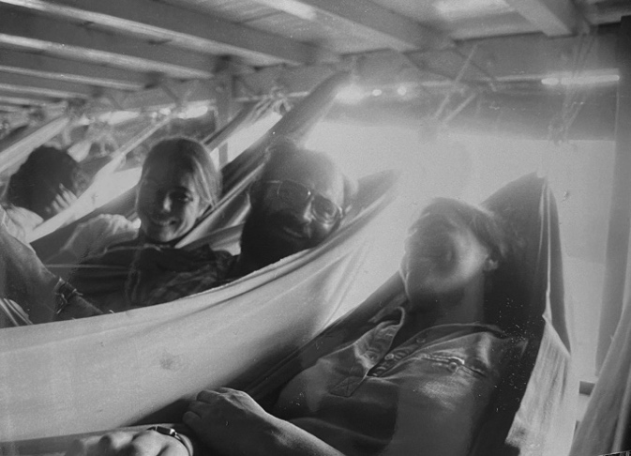
We went out for a coffee…then extended it into a long dinner…and, by the end of the week, we were off an all-night adventure with other internacionalistas on a boat on Lake Nicaragua heading to the southern fishing village of San Carlos. While most passengers slept on the floor, we paid for the luxury of hammocks swinging over their wall-to-wall bodies. We didn’t sleep much, however.
In hammocks on boat on Lake Nicaragua, 1981

We were busy filling in the twelve years since first meeting in Geneva. His family had returned to Uruguay in the early 1970s, but the military seized power in 1973, and a brutal dictatorship had repressed all civil unrest, sending activists either into prison or into exile. My friend Helena, Daniel’s sister, had been apprehended and imprisoned for a year. I visited her in Montevideo soon after her release in late 1975, spending long evenings listening as she detailed the isolation and torture and mental breakdown of those horrendous days. While Daniel was being sought at the same time as his sister, he managed to escape to the airport and on to a flight for Geneva, where he was still living in exile as a convention refugee in 1981.

During that eight-hour overnight boat ride, a million stars our canopy, we not only caught up on the political upheavals that shaped the lives of the Caselli family and of so many Latin Americans during those years of dirty wars and military dictatorships. We also unveiled personal upheavals: in Daniel’s case, a failed marriage; in my case, an almost marriage with a Canadian who seduced me across the border, then eventually left me hours before our wedding, without a partner but with a new country

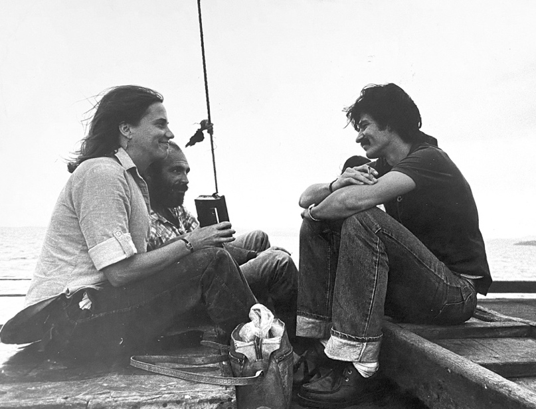
The intensity of those moments: sharing stories of brutal repression, participating in the creation of a ‘new society’ in Nicaragua, swaying in our hammocks, listening to the waves move in circles under the boat, mesmerized by the night sky, moved by the pain of each other’s stories, wooed by the sound of our voices, todo en español (completely in Spanish)….
On the roof of the boat on Lake Nicaragua, 1981

How can one not fall in love in the midst of a revolution…? How can one not fall in love with revolution? Que seductivas son las revoluciones! (Revolutions are so seductive!)

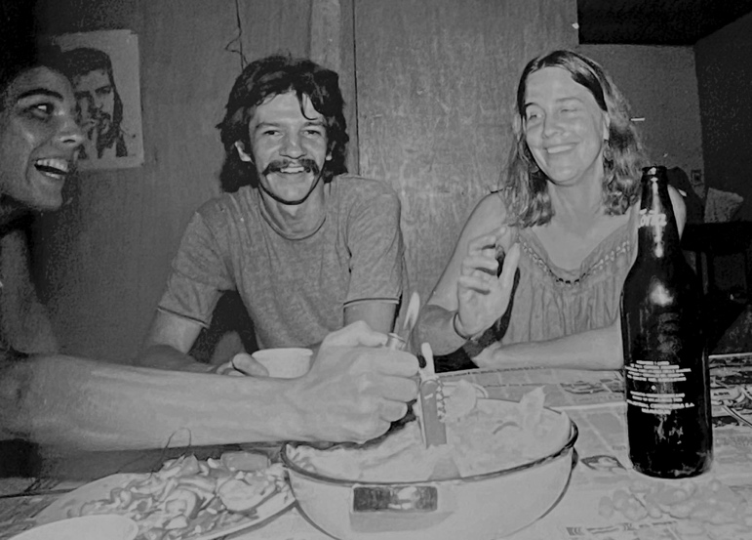
Back in Managua, Daniel moved in with me. We only had a couple of weeks to continue to peel away the layers of our lives, deepening our feelings for each other, before he had to return to Geneva, and I, to Toronto. My contract with the Ministry culminated in the production of Caminemos a magazine for new readers compiled by the literacy teachers I had trained in photo-story production.
Celebrating my 36th birthday in Managua with Mika Seeger

We dreamed of returning to Nicaragua, to work together on similar projects.

Seven rainbows and twelve grapes

The relationship was so fresh, and we wanted to connect outside of the hyper real context of the revolution, by this point already under attack by Reagan’s anti-Sandinista policies and U.S.-funded counterrevolutionaries militarizing the border and inciting division among the population. It was December, winter in Canada and Switzerland, but Spain promised sun, so we decided to meet up in Barcelona over the holidays. Secretly. We were both hesitant to expose our romantic reconnection, until we were clearer about where it was going. I told family and friends that I was heading for a ski holiday in northern Ontario.

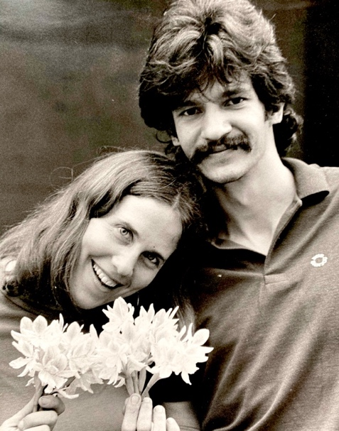
Barcelona. City of Gaudi’s fantastical architecture, of Catalan resistance. A perfect place for a secret rendez-vous with a new lover. We rented a car and followed the Mediterranean coastline to Valencia then headed west into the mountainous region, through the Sierra de Alcatraz. This journey sealed the romance…a magical road trip, during which we counted seven rainbows, before dropping south to Granada, the alluring city of the Moors.

Arriving in the city on Christmas Eve, we found all restaurants closed. We wandered the cobblestone streets til we happed upon a bar…the light and the smell drew us in.. “What’s on the menu?” we asked. “the only food they could offer us was and were reduced to bar fare, a plateful of roasted garlic.

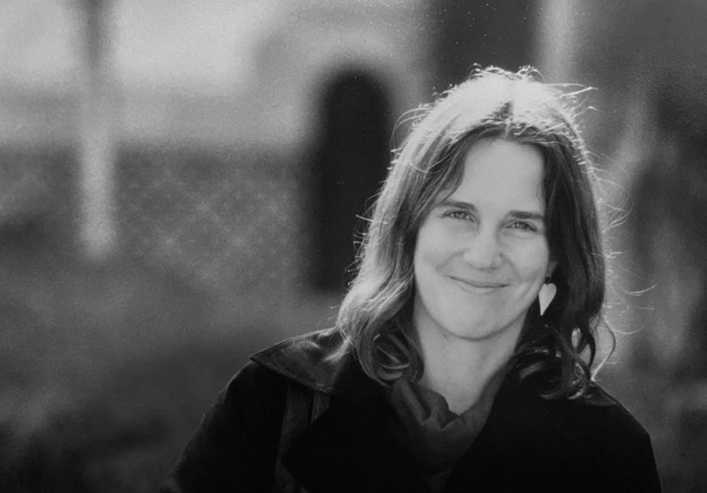
The day after Christmas, we explored the almost mystical Alhambra. Constructed in 889 as an Islamic fortress, by 1492 the Alhambra was the site of the royal court where King Ferdinand and Queen Isabela endorsed Christopher Columbus’s fateful expedition, unleashing the 500 years of European colonization of the Americas. We were tapping the
deeper roots of the contemporary revolutions that drew us together. Inside the Alhambra, Granada, Spain, 1981

Returning to Barcelona, we reconnected with our friends, Ferne and Rob, and roamed the streets of this Catalan capital, drawn to the harbour that was the site of so many Mediterranean encounters. Daniel documented that day in a humorous photo story he sent me later.

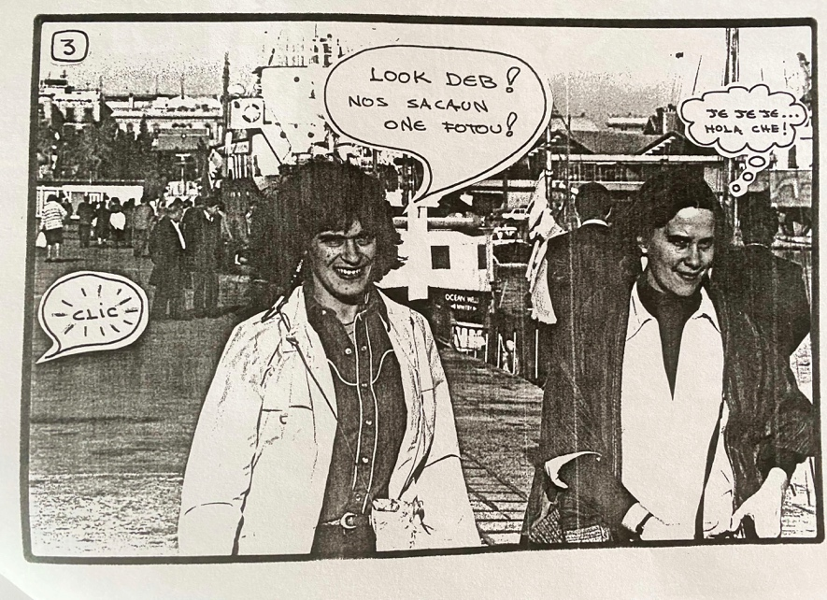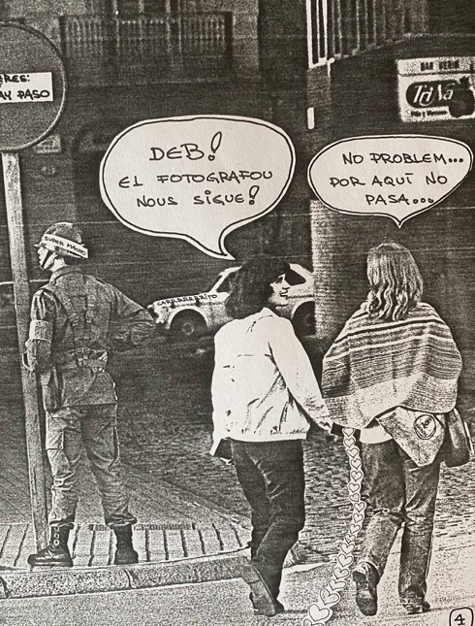
On New Year’s Eve, the four of us met up again to mark the passing of the years. We were joined by Valerie Miller, my co-madre whom I had met in 1978 as she was entering Nicaragua from Costa Rica, in support of the Sandinistas. Padre Fernando Cardenal, eventual Minister of Education, had invited her to be an official historian of the Nicaraguan Literacy Crusade for international audiences, and I had read drafts of her account, Between Struggle and Hope. By coincidence, Valerie was in Paris in December attending an adult education conference in Paris, so slipped south to Barcelona for a visit.

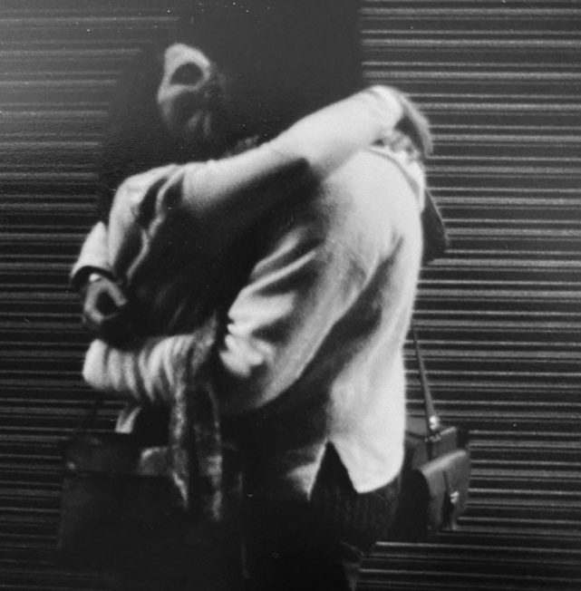
We convened in front of Gaudi’s landmark Sagrada Familia cathedral and walked to the Raval barrio. Daniel led us to a tiny restaurant he knew. Wood paneled ceiling and walls, it was warm and cozy, and we were treated to a Catalan delicacy of rabbit. A few minutes before the strike of midnight, the owner appeared with a tray laden with large grapes. “Eat 12 of these grapes within the first minute of the new year, and your wish will come true,” he promised us. I stuffed them into my mouth with great relish, 12 within 55 seconds! I had been trained to gulp down food both as a child competing with four siblings for cookies, and as a grad student working in a bar in Michigan, where I had met the challenge to swallow 12 pretzels in one minute. The tradition of the 12 grapes continued over the years, and, depending on your beliefs, had significant impact on our lives. I definitely worked for me that night and for other major events in my life…!
Educación popular (popular education) as the connector

Daniel and I left Spain dreaming of ways we could return to Nicaragua as internationalists – together. It was up to me to make it happen. Since 1977, I had been working with activists/academics/artists in the Participatory Research Group. We were part of a budding international participatory research network, affiliated with the International Council for Adult Education (ICAE), which was headquartered in Toronto.

Earlier in 1981, our group had organized a conference “Breaking Ground: Popular Education in Social Movements”, inviting four radical adult educators, including Chico Lacayo, the Vice-Minister of Adult Education in Nicaragua. It was during that visit to Toronto that Chico saw the work we were doing in producing photo stories with immigrant factory workers studying English as a second language. “You could do that with our literacy teachers”, he suggested, and so came the first invitation that took me into the Ministry of Education and that fateful darkroom.

Another featured speaker at that ground-breaking conference was Myles Horton, the founder of the renowned Highlander Research and Education Center in Tennessee, and considered the Paulo Freire of North America. I hosted these two charismatic figures, Chico and Myles, in my home for ten days, along with Valerie Miller as a translator.

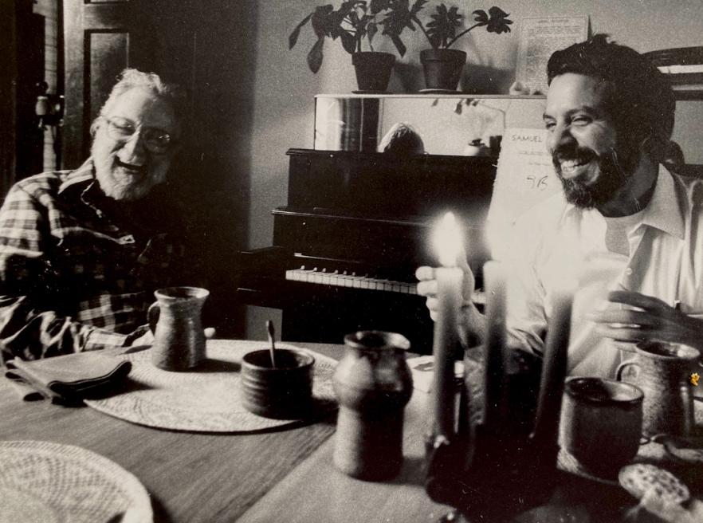
They developed a special bond through long nights of sharing tales of their respective revolutionary exploits in two quite different contexts. Two extraordinary storytellers comparing strategies while embellishing details, aided by Nicaraguan rum and Peruvian pisco. As the friendship deepened, the idea of a joint international gathering in Nicaragua emerged.

Myles had already planted the seed when, by pure chance, I bumped into him in August 1980 in Managua during the official celebration of the completion of the Nicaraguan Literacy Crusade. This “Victory Over Ignorance” party brought 200,000 people into the Plaza of the Revolution – the 60,000 student brigadistas, as well as urban professionals who had been volunteer teachers, the worker and peasant associations, and international visitors.

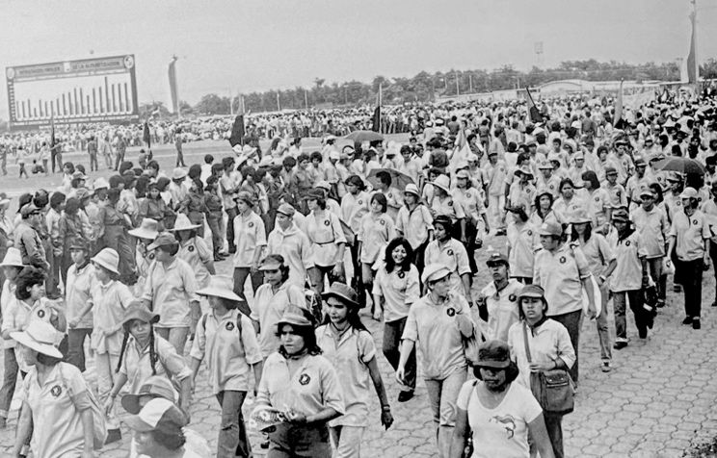
Myles was part of a U.S. delegation and I was there with Canadian Action for Nicaragua, a Toronto-based solidarity group, to witness that historic moment. When Myles and I met at Highlander in 1978, we had begun to imagine a hemispheric gathering of popular educators. “But it can’t be initiated by us in the north,” Myles insisted, recognizing how much we had to learn from the rich experience of popular education in Latin America. “It has to be led by the educadores populares (popular educators) in the south.”

Three years later, the ground was now fertile for Nicaragua to host such a gathering. In the midst of that historic celebration, Myles looked at me and pointing to the overflowing plaza proclaimed “It has to be here!” When the three of us met up in Toronto the following year, Chico pledged to make it happen. But it was a couple of years in the making.

The ICAE supported the revolutionary popular education program of the Sandinistas, and offered me a contract to return in 1983 with the Nicaraguan Ministry of Education to help organize this historic conference on Popular Education for Peace, as well as to deepen the work of participatory curriculum development begun in 1981. Daniel offered specific skills as a graphic artist, so I was able to integrate him into the plans for ongoing workshops in popular communications; we were charged with training literacy teachers in oral history, photography, and silk screen production – practical skills for creating original stories as learning materials.

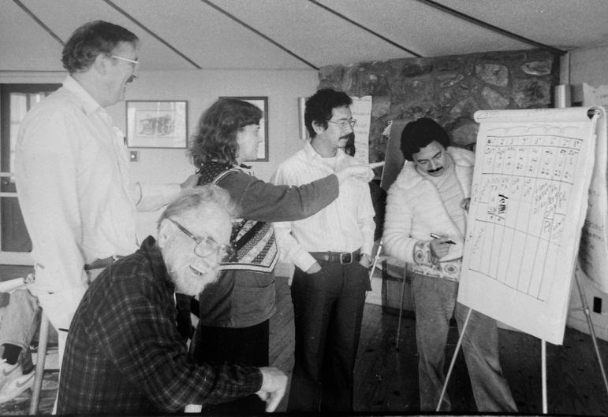
Throughout 1982, we prepared for the upcoming event and for eventually merging our lives. The renowned U.S.-based Highlander Research and Education Center hosted a planning meeting in April, with the new Vice Minister of Adult Education Ernesto Vallecillos (Chico had become Minister of Culture) and other Latin American popular educators. I was part of a small group gathering in the octagonal building overlooking the Cumberland and the Great Smokey Mountains.

Driving to Tennessee through southern Ohio and Kentucky reminded me of my own Appalachian roots, the familiar hamlets in the hollows, rows of wooden shacks along a river valley, smoke rising from the wood stove heating ramshackle houses, old pickup trucks often left to rust near the driveway. The car radio blasted melancholic country music, “He hugged the bottle more than me”, and transported me back to my college years working with war-on-poverty projects in the West Virginia hills in the 1960s.

We organized a tour through these valleys for our Nicaraguan official guest Ernesto, and arranged an interview for him on a home-grown radio station in Whitesburg, Kentucky. “I feel a connection here,” said Ernesto, visibly shaken. “People barely eking out a living on the land, similar to our peasant communities who were the majority and disenfranchised under the Somoza dictatorship. I never imagined I would see such poverty in the midst of the richest nation in the world.”

Indeed, Highlander leaders, such as Myles Horton and Helen Lewis, had been identifying the Third World features of this region, an internal colony, they called it, deep in the belly of the beast. These mountains mined for their rich minerals by absentee landlords, often the same companies operating in Latin America. The familiar pattern of resource extraction while leaving the land in ruins and the residents in dire poverty. Myles saw our international gathering as part of a broader process of linking workers in the Global North and Global South, an opportunity to share knowledge from the ground up, literally and figuratively. In fact, in 1978, we had visited an Alcoa factory in Kentucky with Highlander staff to collect their testimonies of union members about the company’s strategies that we then shared with a social justice group organizing Alcoa workers in northern Brazil. This was cross-border popular education, revealing the global nature of capitalism while feeding local action informed by solidarity with workers in another continent.

The solidarity we were building on Highlander’s hillside was happening in the midst of an extremely hostile environment, with all mainstream media perpetuating then President Ronald Reagan’s denunciation of the Sandinista revolution in the tiny Central American country. Cold war rhetoric was what most Appalachian people heard: “a communist threat to democracy” was at their doorstep. While according to progressive activists countering the rising neoliberal wave, it was “the threat of a good example.” This was the ideological context within which we were planning the hemispheric gathering of Popular Education for Peace. As well as the political dynamic which shaped my return with Daniel to Nicaragua.

In the early months of 1982, an ocean between us, Daniel and I stoked the flames of our simmering passions by snail mail, from Geneva to Toronto and back. Our correspondence was original, and usually took the form of photos fresh from the darkroom transformed into series of postcards or photo stories, with bubble dialogues. Fundamentally, it was a romance created through images and poetic prose. But the content and the backdrop was often the revolution that had sparked our connection and that was seducing us back to participate in that hopeful political experiment. A tiny country that was, as troubadour Luis Enrique Mejia Godoy would memorialize in song, “la garganta de America” or the throat of America. An amplified cry for self-determination, to create a ‘new society’ that was neither capitalist nor communist, but Sandinista.

Testimonios de Nicaragua: A Cross-Canada road trip

There was less anti-Sandinista sentiment in the Canadian media, and a growing network of solidarity activists educating and organizing to bring a different version of the revolution to the public. To my surprise, I was able to secure a grant from the state-funded Canada Council of the Arts to produce a photo exhibit on the innovative education and culture programs of the Nicaraguan government. Both Daniel and I had amassed a collection of images which we culled and curated into a travelling exhibit, which we took across the country between May and July of 1982. Daniel came to Canada so we could produce the photographs and mount them in clusters on 4’ X 6’ panels that could be mounted easily in public places.

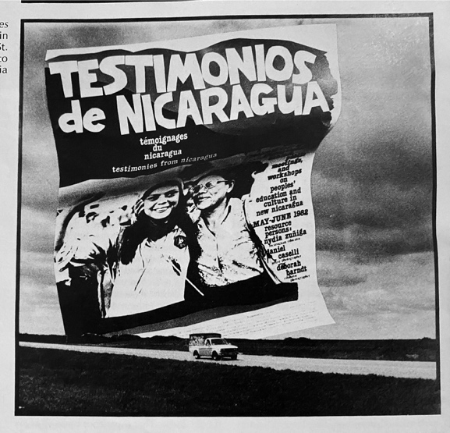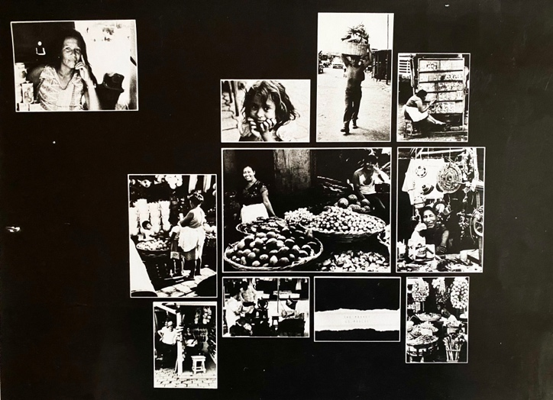

It was a grand adventure, and introduced Daniel to Canada, a country which he would know for only two years. The romance faded, however, and he returned in 1984 to Nicaragua and another woman. Eventually, the romance of that revolution faded as well. But that’s another story.

