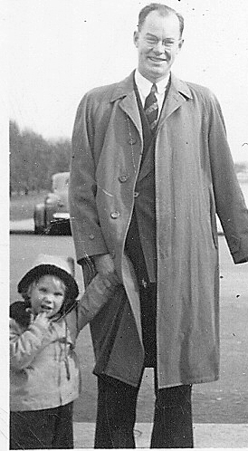
Easter Sunrise

It was our special time
You would awaken me at 4:30 in the morning
And in the darkness and stillness I would get ready
Putting on my new Easter dress and patent leather shoes
A glass of orange juice was all we had before heading out
Leaving Mom, Mike, Kathy and Van still sleeping

Why was it only I, who as a little girl, wanted to come with you
To attend the sunrise service you would officiate at the church?
I hardly remember what happened there or what you said
Something about the stone being rolled away from the grave of Jesus
And his reappearing whole and beautiful, arisen from the dead

My fondest memory, however, was that this was the one time
When I had you all to myself
When you were not off saving the world or managing the church
When I was not competing with three siblings and your wife for your attention
This was something we did together
And I was the one willing to arise in the darkness
To stand beside you and greet the dawn

Now when I cannot phone you to wish you a Happy Easter
Or send you this story to recall our special annual father-daughter connection
I long to believe that when the dark night is erased by the rising sun
You, too, will emerge from your grave
Alive and vibrant, ready to share this quiet morning with me once again

I miss you so much, Dad,
And only through my memories and my words
Can I resurrect you
Is this what is meant by the Christian promise?
That you will be reborn again and again
In my heart…?

Deborah Barndt

Early morning, Easter, April 12, 2009

